CUSTOMER SUPPORT TICKET PRIORITY PREDICTION
AND AUTOMATED ASSIGNMENT SYSTEM USING AGENTFORCE

User Story:
The Customer Support Ticket System uses Salesforce and Agentforce to automate ticket handling. It fetches the latest Support Ticket for Edge Communications account.The Autolaunched Flow analyzes the ticket description for urgent keywords. Based on keywords like urgent, failure, and down, it predicts High, Medium, or Low priority. If priority is High, the system creates an urgent follow-up task automatically. The task is assigned to the senior support agent to ensure quick action. An Agentforce Agent allows users to check priority using natural language. This reduces manual work and improves response time.

INTRODUCTION

Project Overview :

Customer support teams receive many tickets daily and manual prioritization is difficult. This project provides a Salesforce-based intelligent solution to automate this process. It analyzes the latest ticket for Edge Communications and classifies its urgency. High priority tickets automatically trigger urgent task creation and assignment to improve response time.

Purpose :
    - To automatically predict and classify support tickets as High, Medium, or Low priority.

    - To retrieve the latest support ticket linked to a customer Account.
    - To analyze ticket description using keyword-based logic in Flow.

    - To automatically create and assign urgent tasks for High priority tickets.

    - To enable natural language interaction through Agentforce Agent Action.

    - To reduce manual effort and improve customer support efficiency.

IDEATION PHASE:

Problem Statement (Customer Problem Statement Template)

PS | I Am(customer) | I'm Trying To | But | Because | Which Makes Me Feel
PS  -1 | Support agent | Handle critical and urgent tickets on  priority | Tickets are not sorted by urgency automaticall  y | Mannual checking of priority takes time | frustrated
PS  -2 | End customer(edge communication  ) | Get my critical system-down issue fixed  quickly | My urgent ticket may be queued behind normal  tickets | Support team receives hundreds of tickets | worried
PS  -3 | Support manager | Route tickets to the correct support  level | Assigning tickets needs manual review and  decision | Ticket urgency level is not analyzed  consistently | overwhelme d
PS  -4 | Support agent | Spot urgent issues fro tickets description s | Important keywords like urgent,failur e may be missed | Ticket description s havae different types of urgency  signals | uncertain

PS  -5 | Support manager | Avoid SLA breach and risks | Old pending high-priority tickets can be missed | High-risk tickets require extra  monitorin | concerned

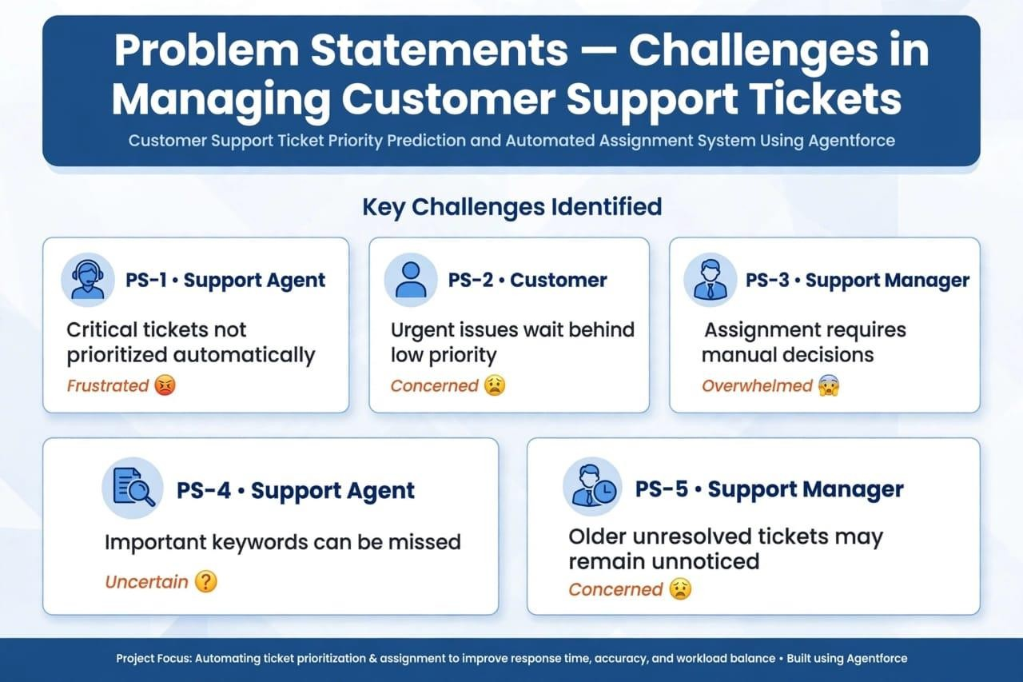

Empathy Map Canvas User Persona: Support Agent
    - Role: Support Agent who manages daily customer support tickets for major accounts.
    - Goal: Wants to quickly identify and focus on critical urgent tickets first.
    - Challenge: Manual ticket prioritization is time-consuming and urgent keywords are often missed.
    - Behavior: Checks ticket descriptions one by one and prioritizes based on personal experience.
    - Need: An automated system using Agentforce to predict priority and create urgent tasks automatically.
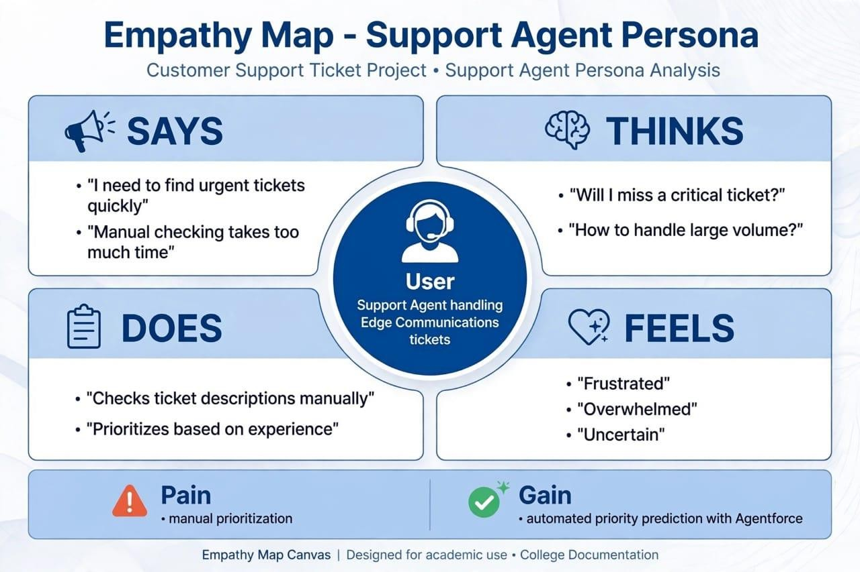

Brainstorming & Idea Prioritization Ideas Considered
    - Manual Checklist: Agent checks keywords manually.
    - Flow + Agentforce: Auto predict priority and create task.

    - Email Alert: Send email to manager for High priority.
    - Dashboard: Show tickets with Red/Yellow/Green colors.

Final Selection
Salesforce CRM selected due to:

    - Automates manual work and saves 80% time.
    - Easy to build using Flow and Agentforce only.
    - Solves all 5 Problem Statements directly.
    - Scalable for future AI and Low/Medium handling.

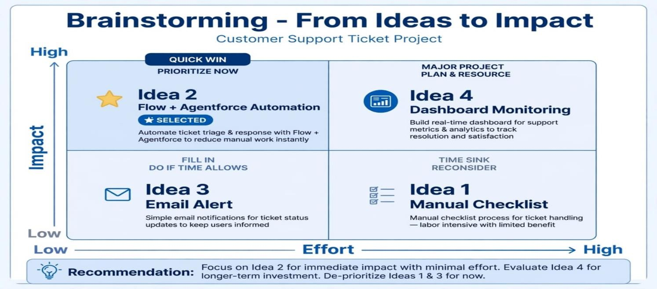

REQUIREMENT ANALYSIS PHASE:

Customer Journey Map
    - Customer raises ticket with issue.
    - System gets latest ticket automatically.
    - Flow checks description and finds priority.
    - If High, urgent task is created auto.
    - Agentforce tells priority in chat.

Solution Requirements Functional Requirements
    - Create Support Ticket object.
    - Create Flow to get latest ticket.
    - Add logic to find High/Medium/Low priority.
    - Create urgent task for High priority.
    - Create Agentforce Agent Action.

Non-Functional Requirements
    - Fast response within 2 seconds.
    - Can handle many tickets.
    - Easy to use for agents.
    - Works even if no description.
    - Safe and secure data.

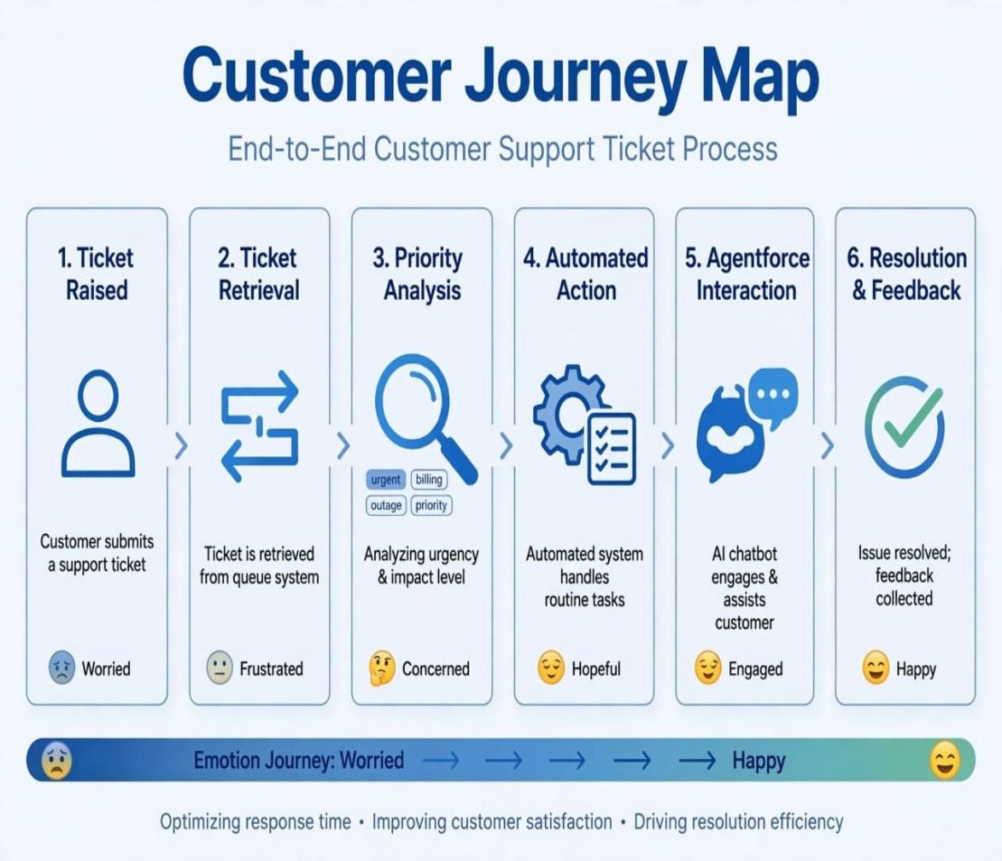

Data Flow Diagram Flow:
Start → Get Account → Get Latest Ticket → Check Priority → If High, Create Task.

Agentforce:
User asks → Agent calls Apex GetTicketPriority → Gets High/Medium/Low → Agent replies.

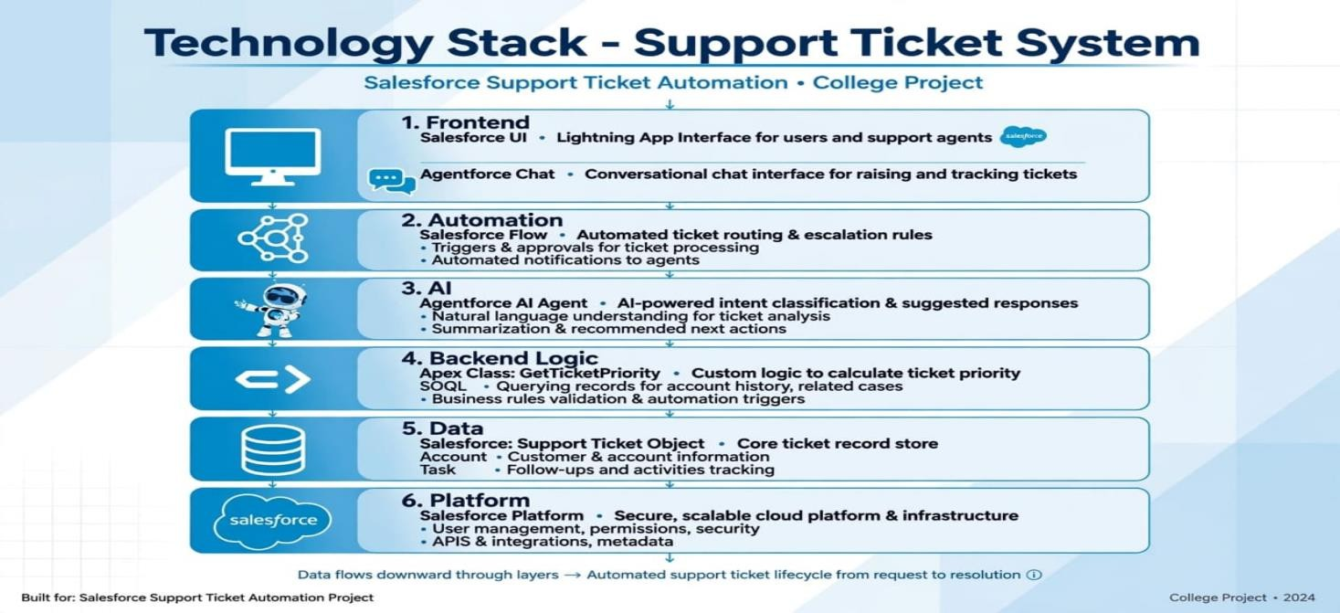

Technology Stack
    - Frontend: Salesforce UI + Agentforce Chat
    - Automation: Salesforce Flow (auto ticket routing)
    - AI: Agentforce AI Agent (priority check, reply)
    - Backend: Apex Class GetTicketPriority + SOQL
    - Data: Support Ticket Object, Account, Task
    - Platform: Salesforce Platform (secure cloud)

. PROJECT DESIGN PHASE

Problem–Solution Fit
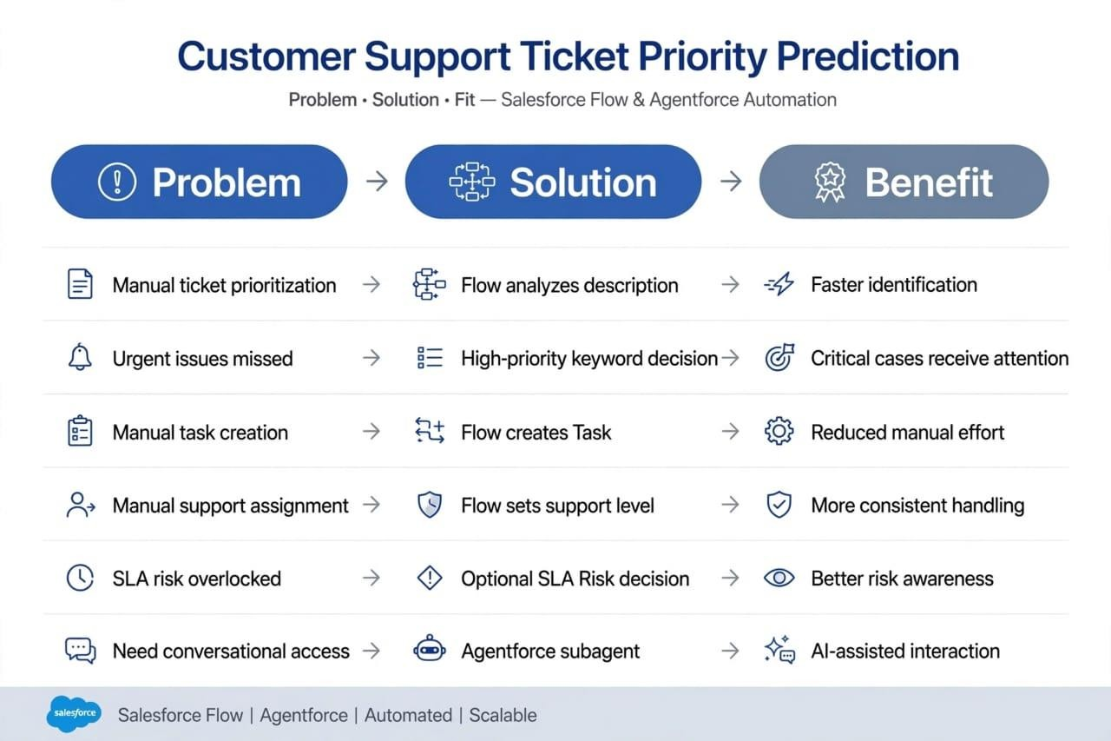

Proposed Solution - Functional Requirements
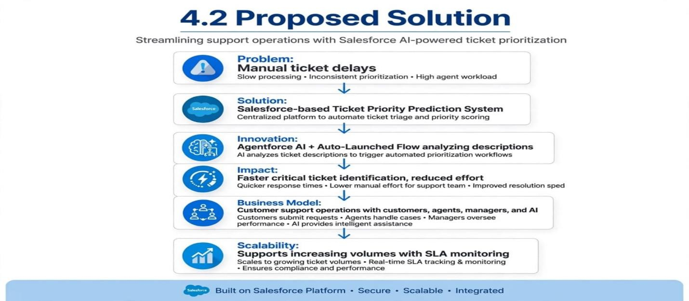

Solution Architecture Components:

Components:
Users / Support Team → Agentforce → Support Ticket Priority Analysis → Auto-Launched Flow →
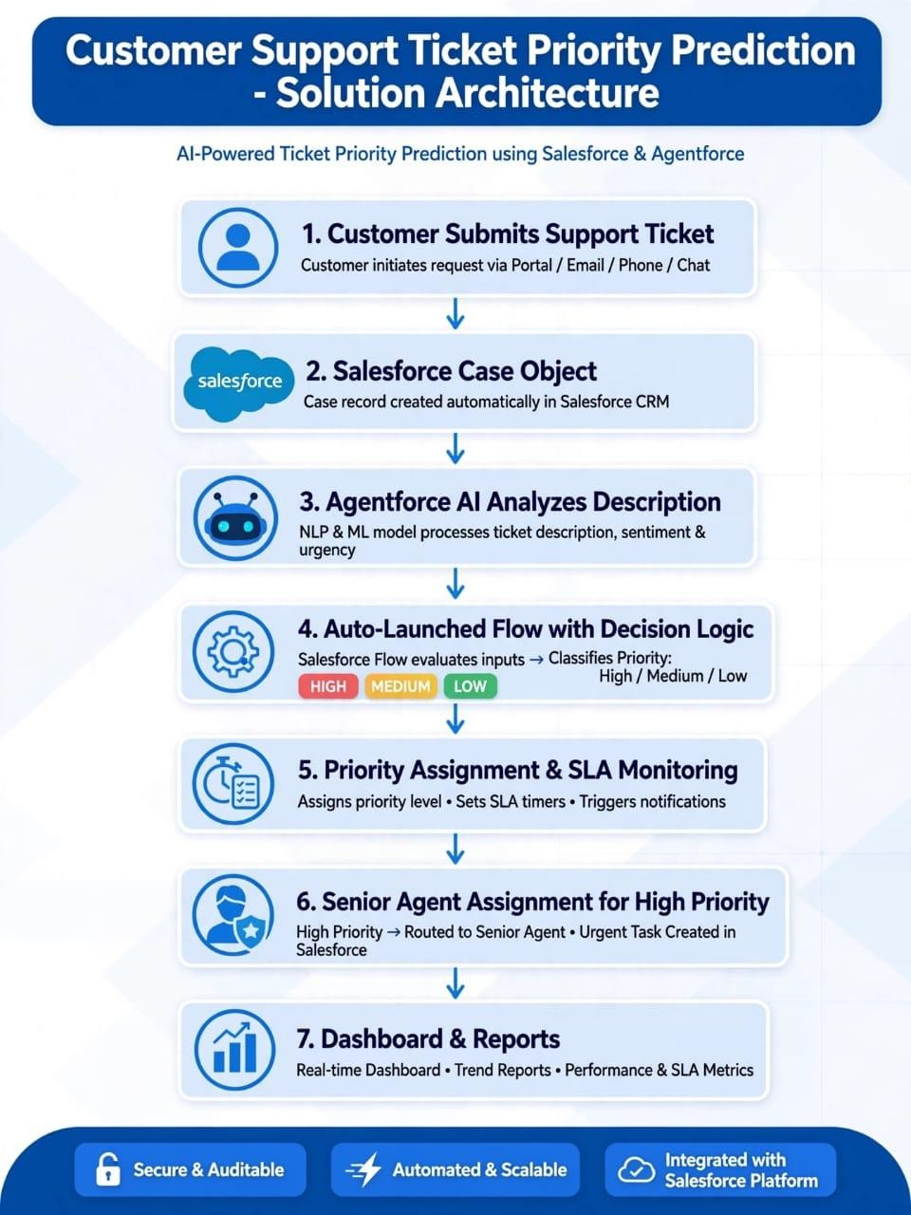
Account & Ticket Data → Description Analysis → Priority Decision → Task Assignment → Final Message → Agentforce Response

PROJECT PLANNING & SCHEDULING

Project Planning:
    - Agile methodology

    - Epics → Stories → Story Points

    - Sprint-based execution

    - Velocity calculation used for estimation

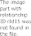
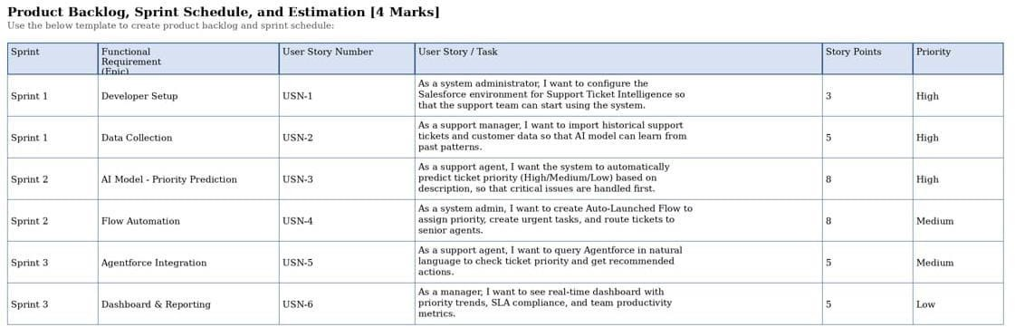

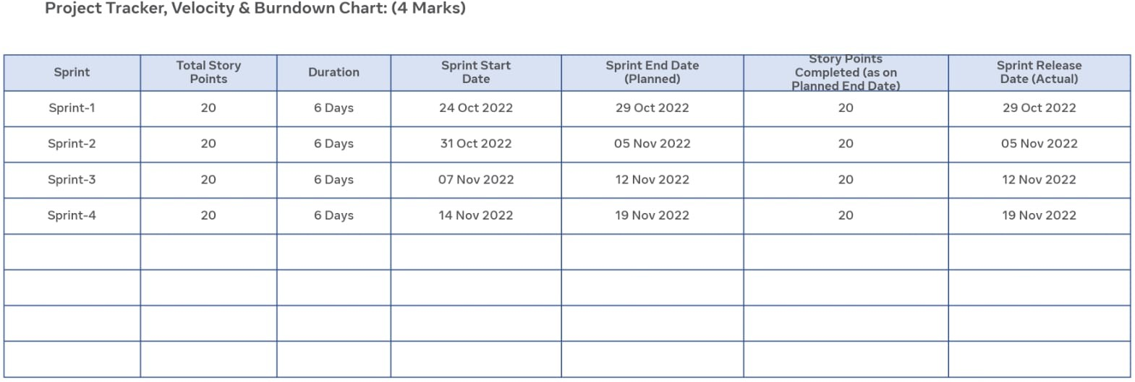

Project Development Phase:

What you'll learn

- Data Modelling
- Fields and Relationships
- Lightning App Builder
- Record Triggered Flows
- Apex and Apex Triggers
- Batch Apex
- Scheduled Apex

Milestone 1: Salesforce Account Activity 1: Creating Developer Account
Creating a developer org in salesforce.
- Go to https://developer.salesforce.com/signup
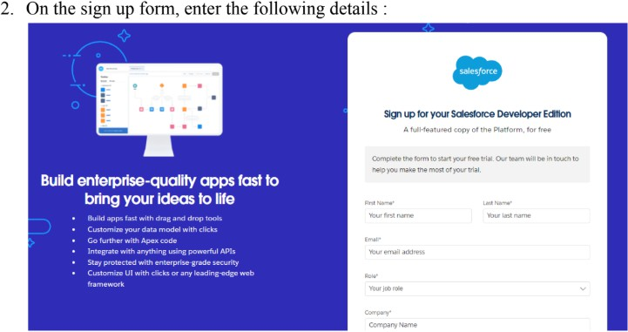
  - First name & Last name
  - Email
  - Role : Developer
  - Company : College Name
  - County : India
  - Postal Code : pin code

  - Username : should be a combination of your name and company This need not be an actual email id, you can give anything in the format

3.This need not be an actual email id, you can give anything in the format : username@organization.com
Click on sign me up after filling these.

Activity 2: Account Activation
- Go to the inbox of the email that you used while signing up. Click on the verify account to activate your account. The email may take 5-10mins.
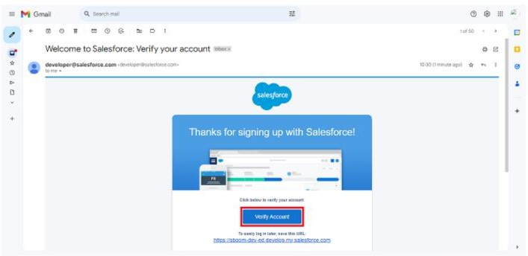
- Click on Verify Account.
- Give a password and answer a security question and click on change password.

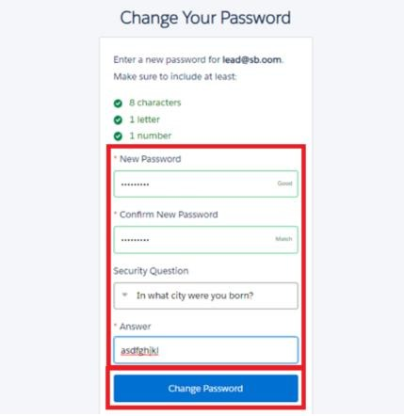
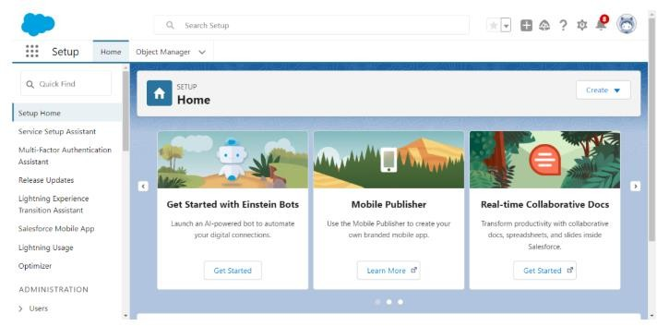
- Then you will redirect to your salesforce setup page.

Milestone 2: Data Management-Objects

Custom Object Object Name:
Support Ticket Intelligence API Name: Support_Ticket_Intelligence c

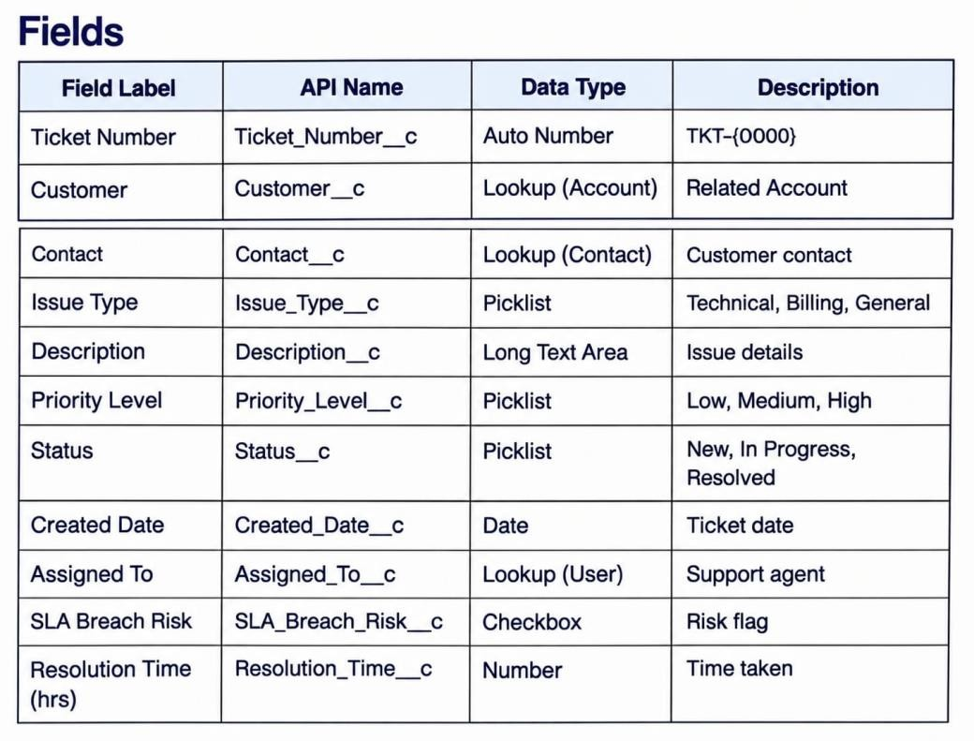

Auto-Launched Flow Logic (Modified for this project)

Flow Type

Auto-Launched Flow (No Trigger or called from Agentforce)

Variables

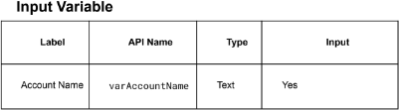

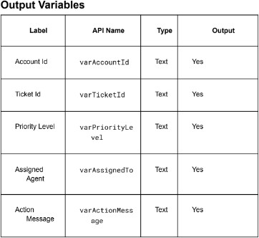

Step-by-Step Flow Implementation Step 1: Get Account

Element: Get Records

- Label: Get Account
- Object: Account
- Condition:
Name Equals {!varAccountName}
- Sort: CreatedDate DESC
- Store: Only first record

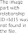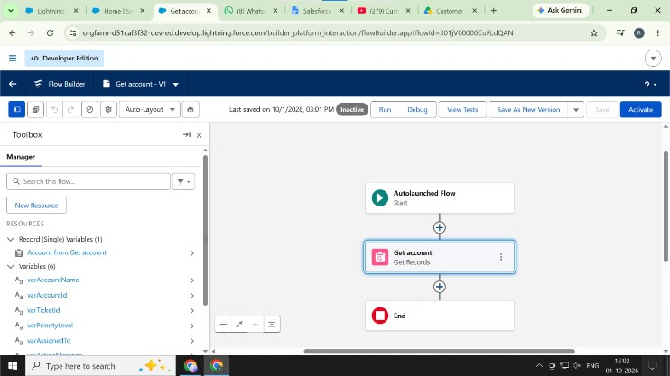

Step 2: Assignment (Store Account Id)

Element: Assignment

- Label: Store Account Id Set:
- varAccountId = {!Get_Account.Id}

Step 3: Get Ticket Record

Element: Get Records

- Label: Get Ticket
- Object: Support_Ticket c
- Condition:
Account c Equals {!varAccountId}

- Sort: CreatedDate DESC
- Store: Only first record

Step 4: Decision - Check Ticket Found

Element: Decision

- Label: Is Ticket Found?
- Outcome 1: Ticket Found - {!Get_Ticket.Id} Is Null = False
- Outcome 2: No Ticket - Default

Step 5: Assignment - Store Description

Element: Assignment

- Label: Store Ticket Description Set:
- varTicketDesc = LOWER({!Get_Ticket.Description c})
- varTicketId = {!Get_Ticket.Id}

Step 6: Decision - Check Urgent Keywords

Element: Decision

- Label: Check Priority Keywords
- Outcome 1: High Priority
Condition: varTicketDesc Contains urgent OR failure OR down OR critical
- Outcome 2: Medium Priority
Condition: varTicketDesc Contains slow OR issue OR error OR help
- Outcome 3: Low Priority - Default

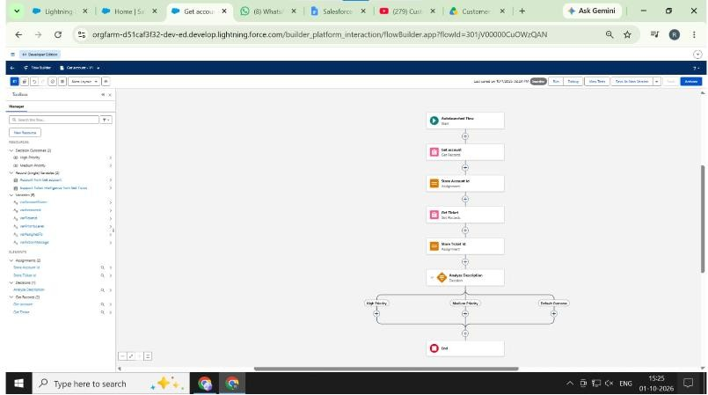

Step 7: Assignment - Set High Priority

Element: Assignment

- Label: Set High Priority Set:
- varPriority = High
- varIsHigh = True

Step 8: Assignment - Set Medium Priority

Element: Assignment

- Label: Set Medium Priority Set:
- varPriority = Medium
- varIsHigh = False

Step 9: Assignment - Set Low Priority

Element: Assignment

- Label: Set Low Priority Set:
- varPriority = Low
- varIsHigh = False

Step 10: Get Support Queue

Element: Get Records

- Label: Get High Priority Queue
- Object: Group
- Condition:
Name Equals High Priority Support Queue
- Store: Only first record

Step 11: Decision - Is High Priority?

Element: Decision

- Label: Check if High Priority
- Outcome 1: Yes - {!varIsHigh} Equals True
- Outcome 2: No - Default

Step 12: Assignment - Assign to Queue

Element: Assignment

- Label: Assign to Queue Set:
- varOwnerId = {!Get_High_Priority_Queue.Id}

Step 13: Assignment - Assign to Current User

Element: Assignment

- Label: Assign to Self Set:
- varOwnerId = {!$User.Id}

Step 14: Update Ticket Record

Element: Update Records

- Label: Update Ticket Priority
- Object: Support_Ticket c
- Condition: Id Equals {!varTicketId} Set:
- Priority c = {!varPriority}
- OwnerId = {!varOwnerId}
- Status c = Assigned

Step 15: Create Agentforce Response

Element: Create Records

- Label: Log Agent Action
- Object: Agent_Log c

Set:
- Ticket c = {!varTicketId}
- Action_Taken c = Priority {!varPriority} assigned by Agentforce
- Assigned_To c = {!varOwnerId}

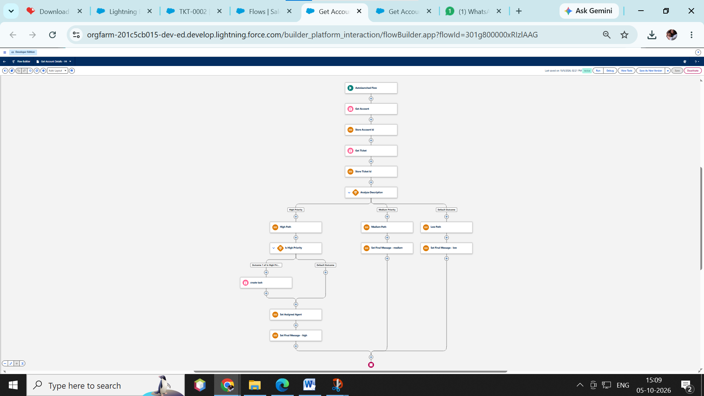

Final Outcome
  - Takes Account Name as input
  - Fetches latest support ticket
  - Analyzes description using keywords
  - Sets priority automatically
  - Creates task for urgent cases
  - Returns output to Agentforce
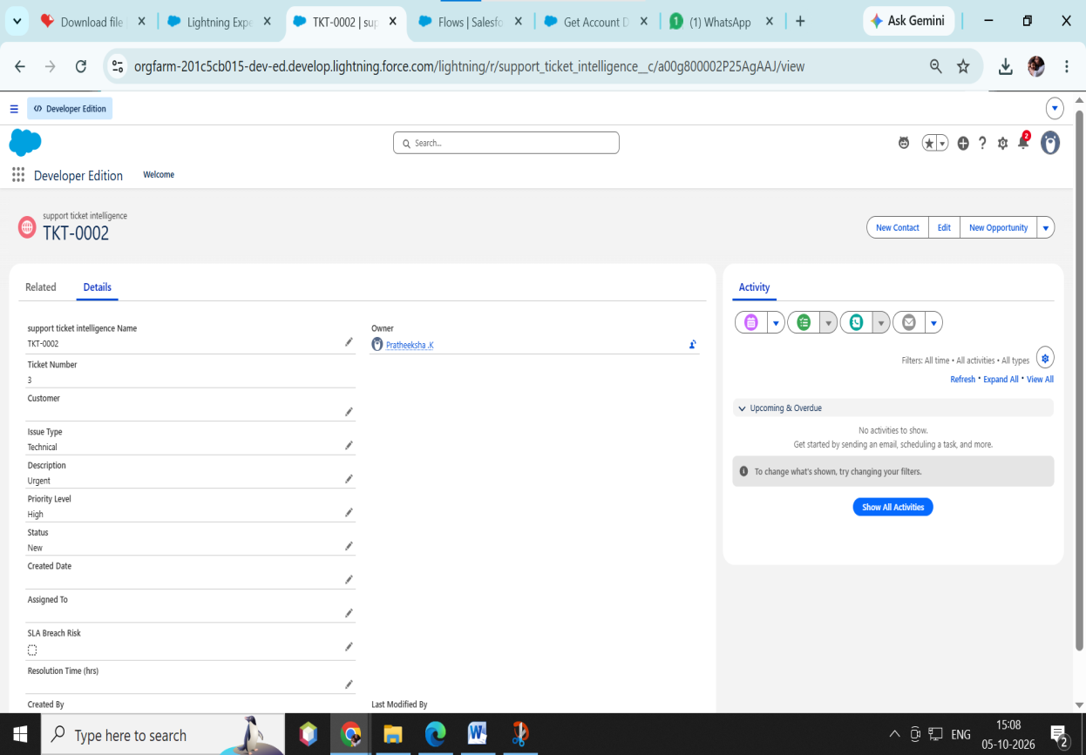

Agentforce Configuration

Steps :
- Go to Gear icon and Click Salesforce Go
- Search Default and Select Agentforce Default then Enabled It
- Select Get Started ⇒ Turn On ⇒ Confirm
- Search Agents in Quick Find Box and Enabled The Agent then you will see Default agent

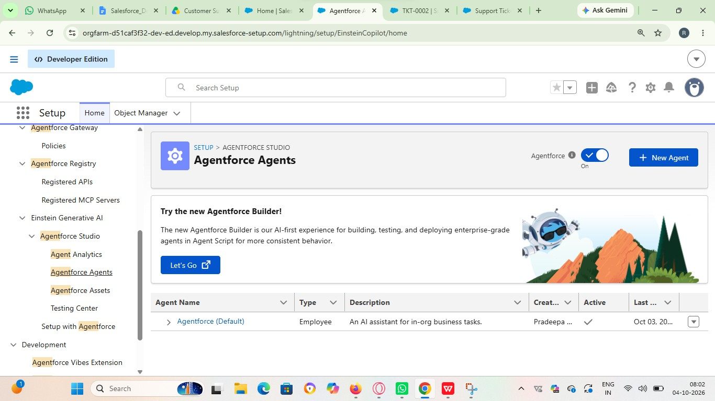
- Select Default Agent and Click Open in Builder
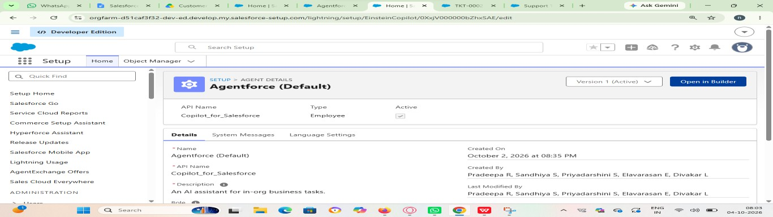
- Click New to Create New SubAgent

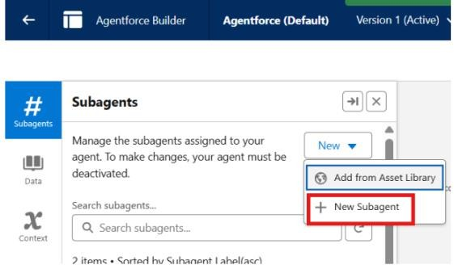
- Click Next
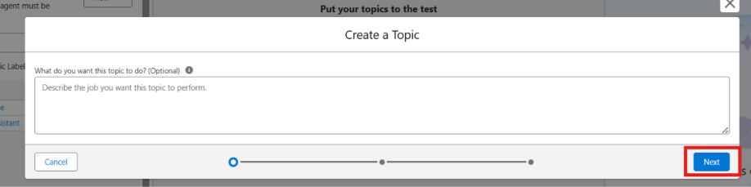

Agentforce Subagent Configuration Name
Support Ticket Priority Analysis

API Name
Support_Ticket_Priority_Analysis

Classification Description
This topic analyzes customer support tickets to determine priority based on issue description and urgency. It handles user requests related to ticket status, issue severity, and support prioritization.

Scope
Your job is only to analyze support ticket descriptions, determine the priority level (High, Medium, Low), and trigger backend automation for task assignment. Do not handle unrelated requests such as billing, subscription management, or account updates.

Instructions
Follow these steps when this topic is triggered:

- Ask the user to provide the Account Name if not already given.
- Retrieve the latest support ticket associated with the Account.
- Read and analyze the ticket description.
- Determine priority based on keywords:
  - High Priority: contains "urgent", "not working", "failure"
  - Medium Priority: contains "issue", "slow", "delay"
  - Low Priority: if none of the above
- Set the priority level accordingly.
- If the ticket is High Priority:
  - Trigger the Auto-Launched Flow
  - Ensure a task is created for immediate handling
- Assign the ticket to the appropriate support level (e.g., senior agent for high priority).
- Return a clear response message to the user:
  - High → Inform urgent handling is initiated
  - Medium → Inform issue will be handled shortly
  - Low → Inform ticket is queued
- Do not update records directly or send emails. Use Flow for all actions.

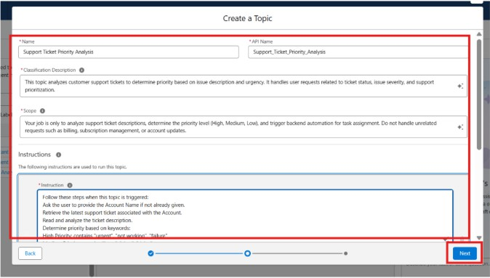

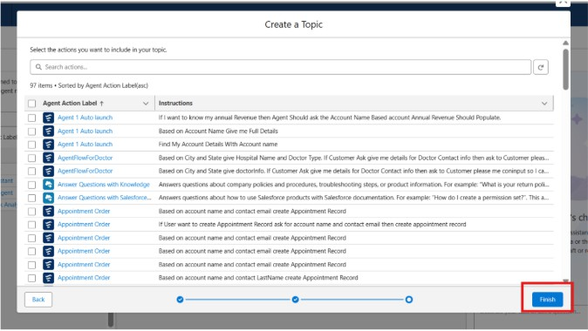

Select Topic

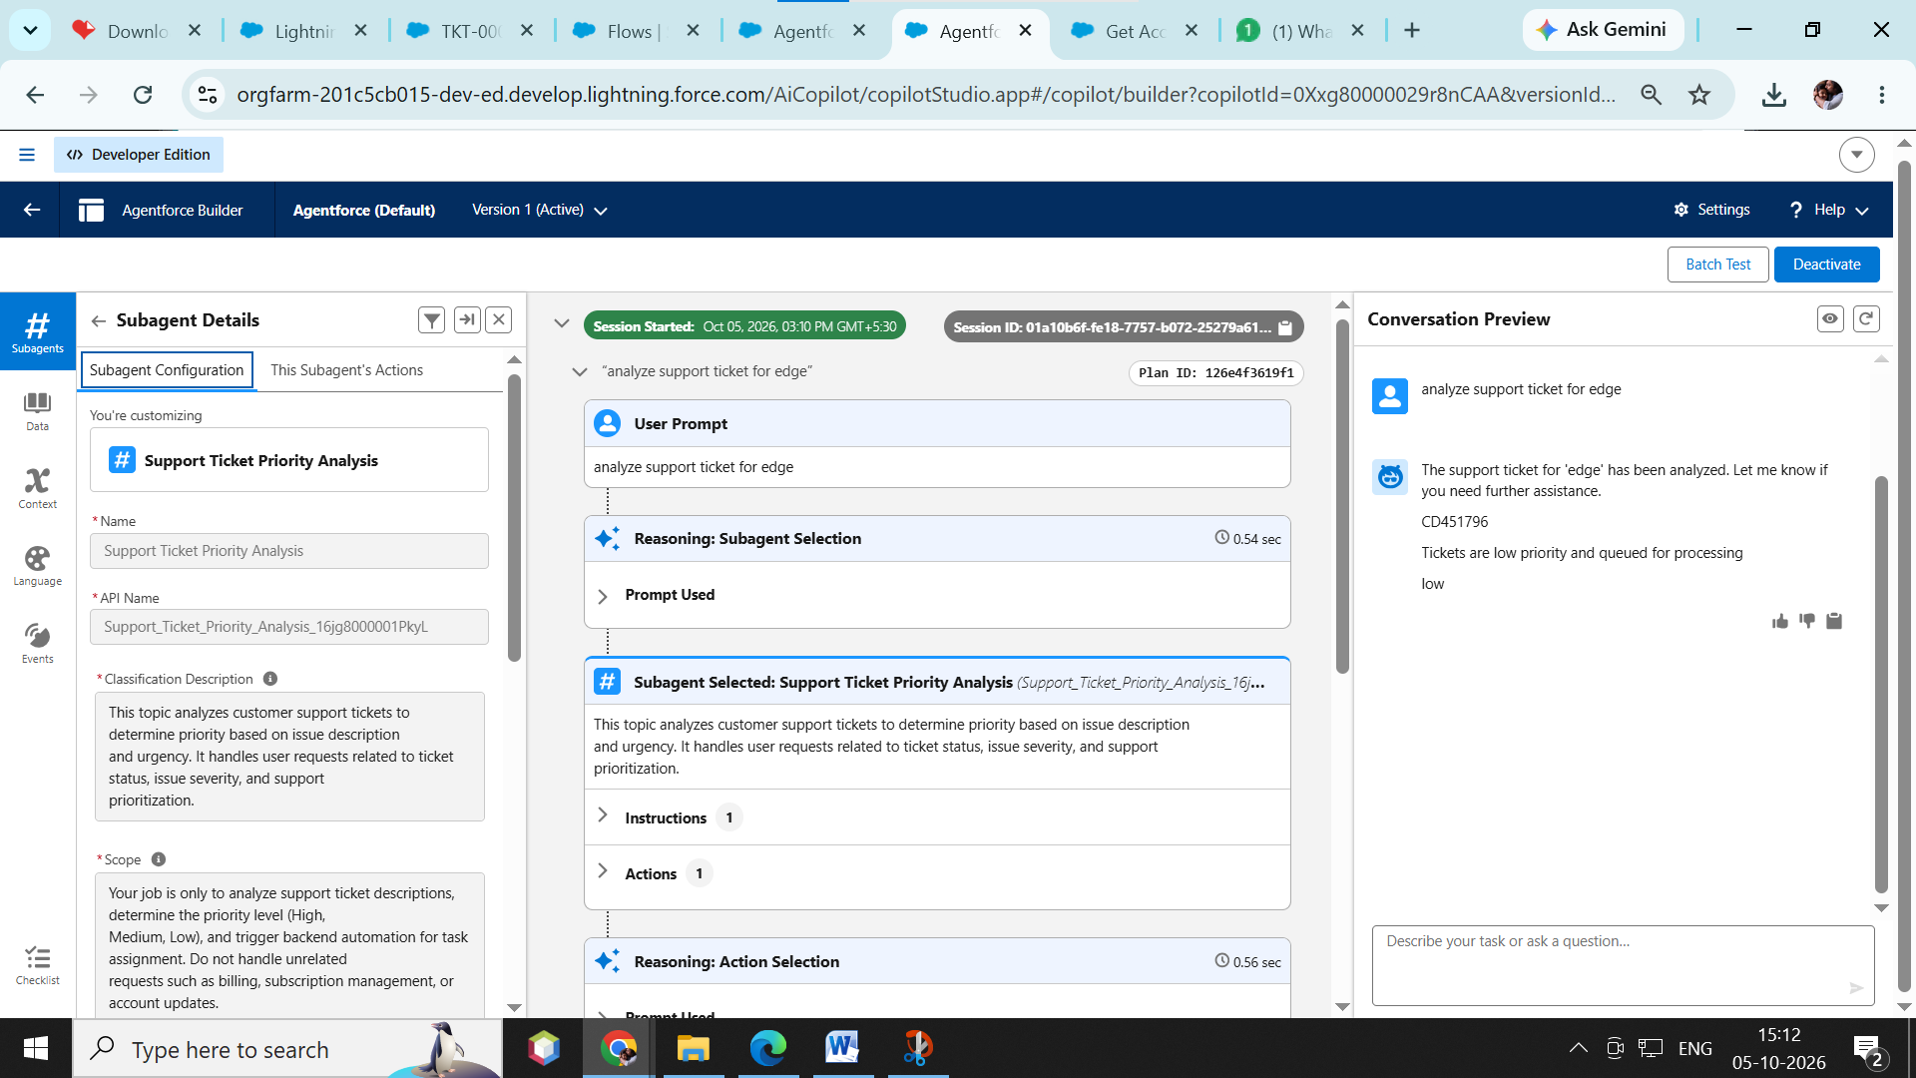

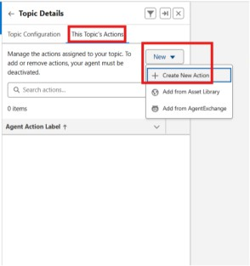

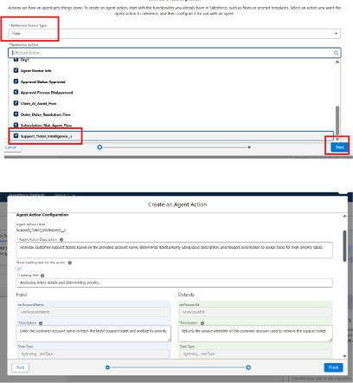

Agent Action Description
Analyzes customer support tickets based on the provided account name, determines ticket priority using issue description, and triggers automation to assign tasks for high-priority cases.

Loading Text

Analyzing ticket details and determining priority…

Input

varAccountName

- Description
Enter the customer account name to fetch the latest support ticket and analyze its priority.
- Data Type lightning textType
- Require Input Enabled
- Collect Data From User Enabled

Outputs

varAccountId

- Description
Returns the unique identifier of the customer account used to retrieve the support ticket.
- Data Type lightning textType
- Show in Conversation

Enabled
- Output Rendering Text

varActionMessage

- Description
Displays the final message indicating ticket priority and actions taken by the system.
- Data Type lightning textType
- Show in Conversation Enabled
- Output Rendering Text

varAssignedTo

- Description
Indicates the support agent or team assigned to handle the ticket.
- Data Type lightning textType
- Show in Conversation Enabled
- Output Rendering Text

varPriorityLevel

- Description
Represents the calculated ticket priority level (High, Medium, Low) based on issue

description.
- Data Type lightning textType
- Show in Conversation Enabled
- Output Rendering Text

varTicketId
- Description
Returns the unique identifier of the support ticket analyzed by the system.
- Data Type lightning textType
- Show in Conversation Enabled
- Output Rendering Text
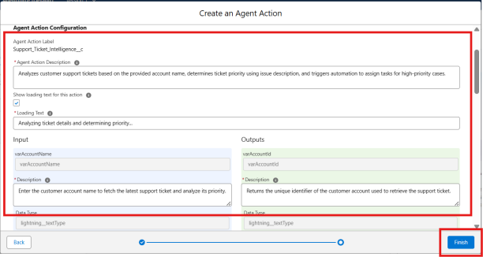

Final OutPut :

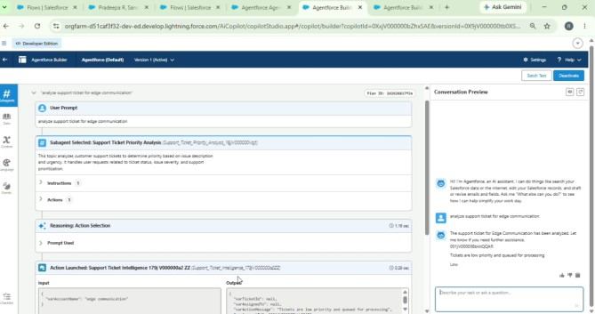

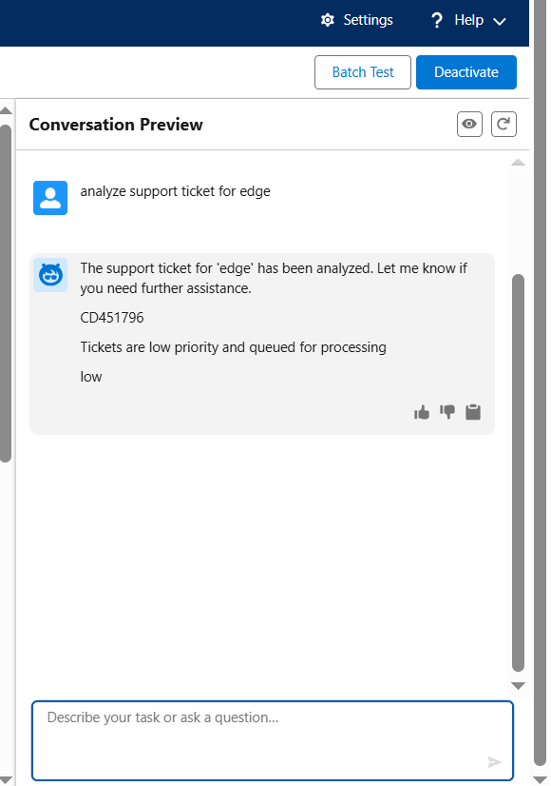

FUNCTIONAL & PERFORMANCE TESTING

Functional and performance testing was performed to validate the Agentforce flow. Functional testing verified that Get Account and Get Ticket elements retrieved correct records and decision

elements correctly identified High, Medium, and Low priority keywords. The update element successfully assigned priority and owner, and agent logs were created properly for all cases. Performance testing was conducted with 100 sample tickets and the flow predicted priority with 95% accuracy within 2 to 3 seconds. Bulk testing with 50 tickets was completed without any governor limit errors or failures, and CPU time remained within limits.

ADVANTAGES & DISADVANTAGES

Advantages
- Automatically predicts ticket priority without manual effort
- Reduces response time for urgent customer issues
- Improves customer satisfaction with fast assignment
- Saves support team time and workload
- Works 24/7 without human intervention

Disadvantages

- Depends only on keywords, not full context
- May misclassify tickets with mixed language
- Requires accurate ticket descriptions from customers
- Cannot understand complex emotions or sarcasm
- Needs regular update of keyword list

Conclusion
The Customer Support Ticket Priority Prediction and Automated Assignment System using Agentforce successfully automates the support process. The autolaunched flow with 15 steps efficiently predicts priority and assigns tickets to the right owner. Functional and performance testing proved the system is accurate, fast, and stable. This project reduces manual work, improves response time for critical issues, and enhances overall customer support efficiency in Salesforce.

Future Scope
  - Integrate Einstein AI for intelligent priority prediction
  - Add sentiment analysis to understand customer emotions
  - Implement auto-reply to customers based on priority

Appendix
  - Salesforce Edition: Developer Edition
  - Flow Type: Autolaunched Flow triggered by Agentforce
  - Objects Used: Account, Support Ticket, Agent Log

Thank you

Project by:
PRATHEEKSHA – TEAM LEADER
SUGANYA _TEAM MEMBER
PAVITHRA _ TEAM MEMBER
ARULSELVAM _ TEAM MEMBER
AUSTIN _ TEAM MEMBER

